**QA GA Checklist -**

**GA checklist –** Once Milestone is done it expected from the Manager/Leader to fill out the GA Checklist that is part of the parent Project REL (Release Management).

**Latest QA Checklists by project (For reference) –**

VidyoDesktop – <https://jira.vidyo.com/browse/REL-729> (3.6.9.014)

VidyoWeb - <https://jira.vidyo.com/browse/REL-660> (1.3.10.005)

VidyoMobile iOS –<https://jira.vidyo.com/browse/REL-1456> (2.2.4.153)

VidyoMobile Android - <https://jira.vidyo.com/browse/PDM-4592> (2.5.2.001)

1 – In TestRail – Select the Milestone and focus on it – then click on “Reports” -> “Summary”

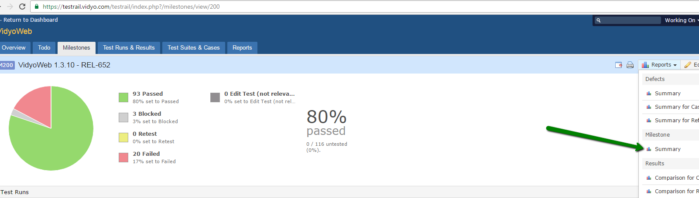

2 – Give your report an indicative name such as “ProjectName+ReleaseVersion” (“VidyoWeb1.3.10”)

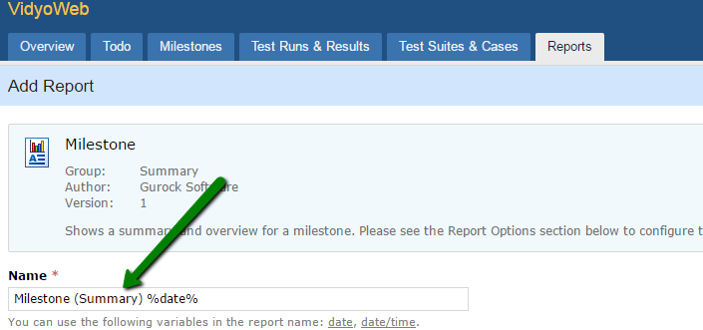

3 – In section “Report Options” – Choose - > “Tests” tab – and select from dropdown menu – “All” 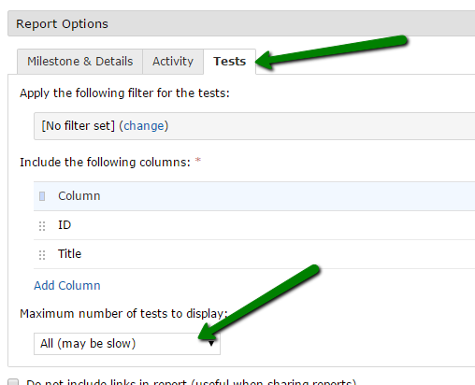

4 – Click the “Add Column”

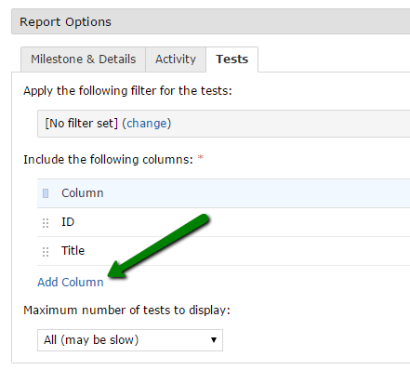

5 – Select the desired column from the dropdown menu –

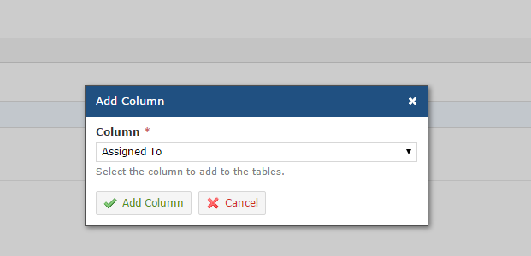

**Projects should include the following Columns –**

**VidyoDesktop –** Portal, Operating System, Headset/Mic/Speaker, Camera

**VidyoWeb Project should include –** Portal, Browser, Browser architecture, Operating System, Headset/Mic/Speaker, Camera

**VidyoMobile iOS Project –** Portal, iOS Device, iOS Version, Headset/Mic/Speaker

**VidyoMobile Android Project –** Portal, Android Device, Android Version, Headset/Mic/Speaker

6 – In section – “Access & Scheduling” – Select the 2nd radio button “Everyone”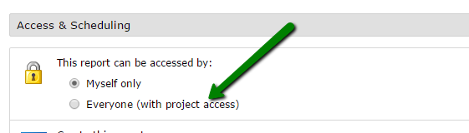

7 – Click the “Add Report”

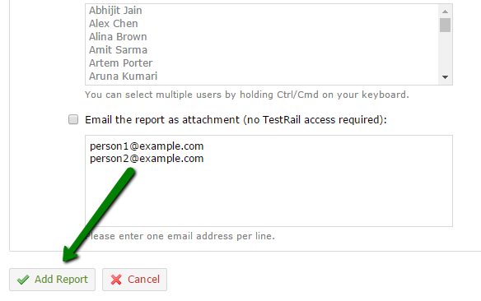

8 – New report will appear then under “Reports” tab

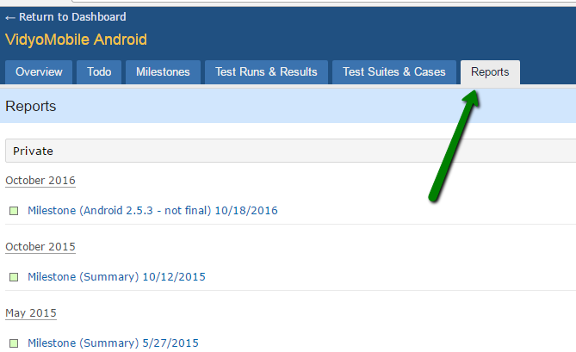

Links to JIRA Filters (example is for VidyoDesktop project) -

Customer Detected Resolved Issues - <https://jira.vidyo.com/issues/?filter=15188>

Known Issues - <https://jira.vidyo.com/issues/?filter=15187>

**This is the logic for each:**

Customer Detected Resolved Issues -

project = VD AND issuetype = Bug AND status = Complete AND resolution in (Fixed, Resolved) AND fixVersion = 3.6.9 AND "Customer Detected" = Yes

1. Known Issues -

project = VD AND issuetype = Bug AND status in (Reopened, New, Assigned, Archived, "Development In Progress", "QA In Progress") AND affectedVersion = 3.6.9 AND "Knowledge Base" = "Internally+Externally" ORDER BY priority DESC

Thanks,

Liat Gibli